Data Visualisation and Executive Communication
Seven primary visualisation techniques were employed, each chosen for clarity and executive suitability. Some of them are done in python and some in PowerBi.

Line charts (closing prices over time)
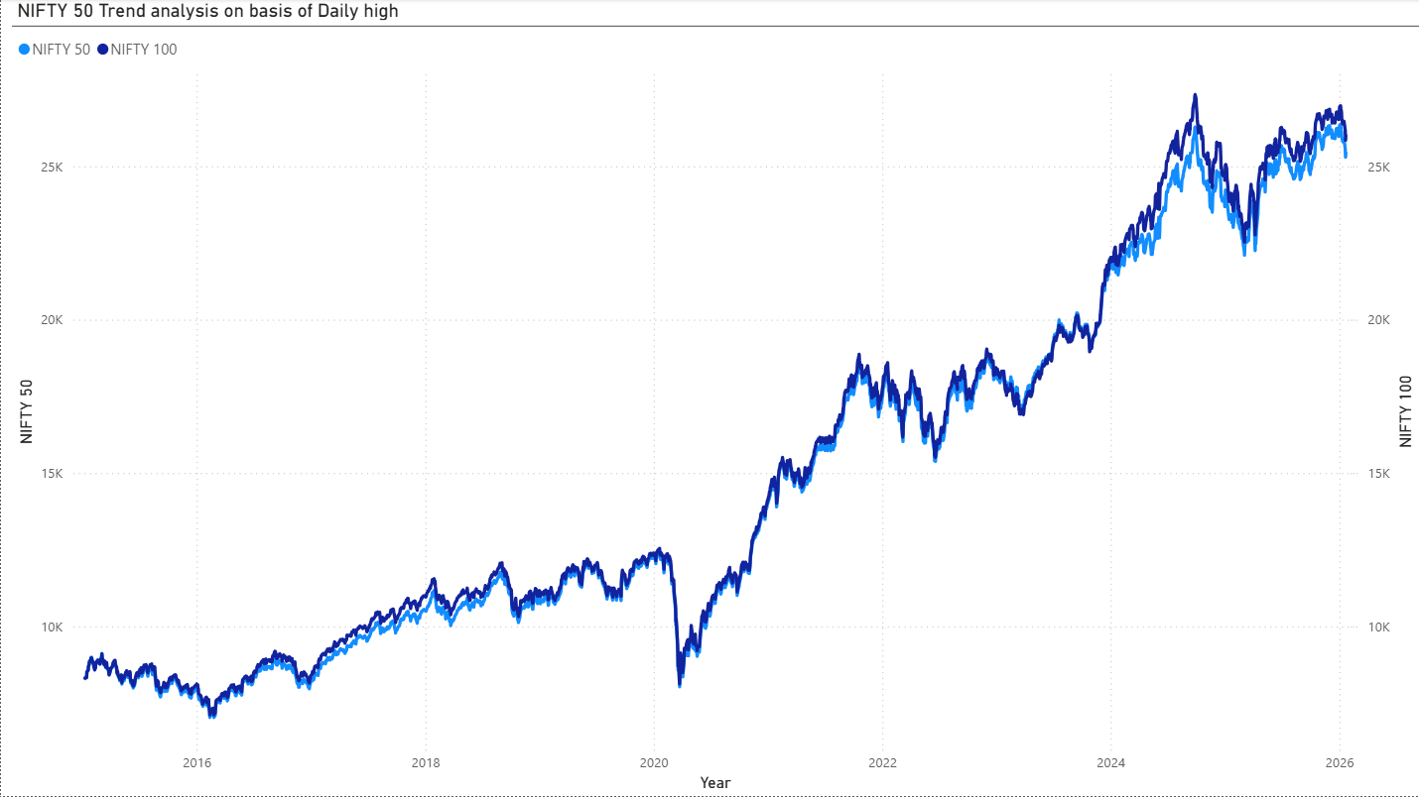
Justification: The line trend chart was selected as the primary visualisation for displaying long-term price movements across NIFTY50, NIFTY100. Line charts are the standard choice for continuous time-series data in finance, as they clearly reveal trends, growth trajectories, and periods of divergence or convergence. By plotting two indices on the same graph, the visual enables quick visual comparison of relative performance and co-movement over the 10+ year period.

Box plots (distribution of close price by index)
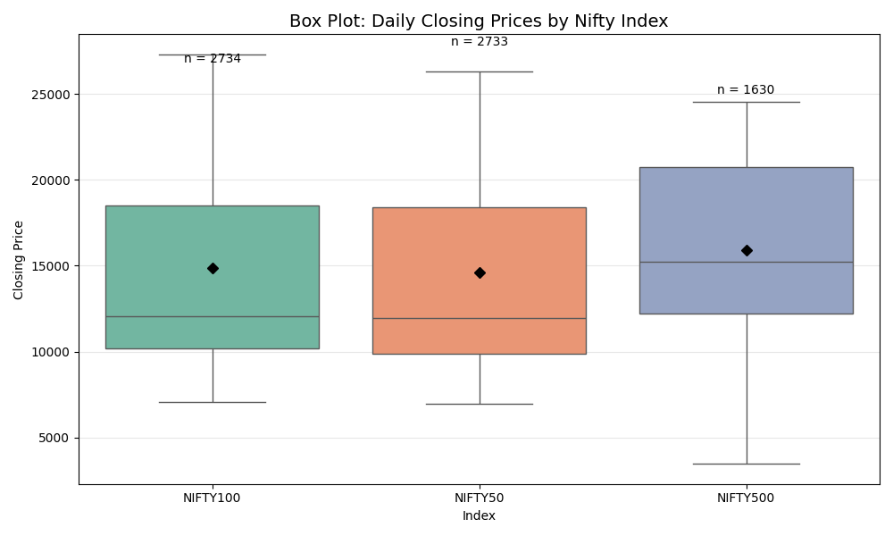

Justification: The combined box plot was selected to summarise the distribution of daily closing prices across the three indices in a single, comparative visual. Box plots efficiently communicate central tendency (median), average (mean marker), spread (IQR), range (min-max whiskers), and outliers — all critical for understanding price variability and risk. The side-by-side layout allows executives to quickly compare dispersion and extreme values (e.g. NIFTY500’s wider range and more outliers).

Heatmaps (correlation matrices)
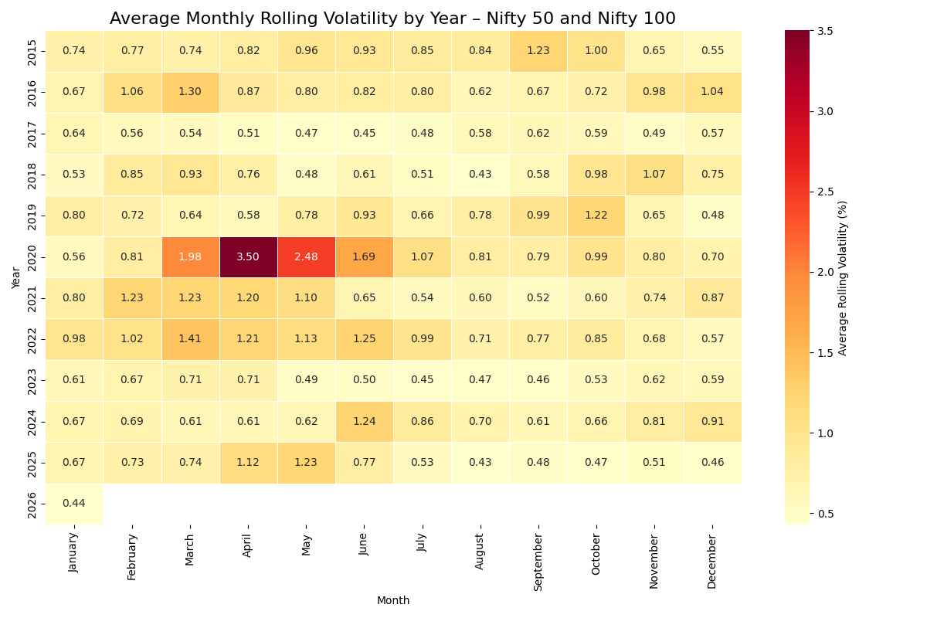
Justification: The heatmap was chosen to present the full correlation matrix (both prices and returns) in a compact, colour-coded format. Heatmaps are highly effective for displaying multi-dimensional relationships at a glance, with warmer colours indicating stronger positive correlations. This visual allows executives to immediately identify the tightest relationships and relative differences across pairs.

Scatter plots with regression lines
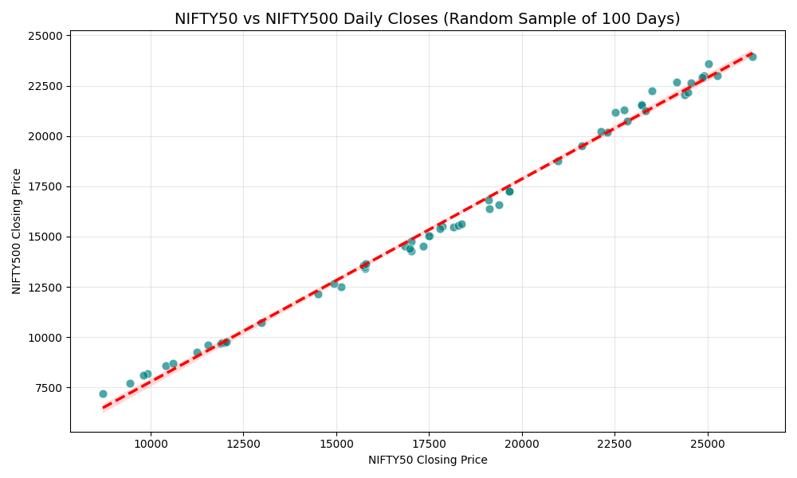
Justification: The scatter plot, enhanced with a regression line, was selected to visually demonstrate the strength and direction of the relationship between pairs of indices ( NIFTY50 vs NIFTY500 closing prices). Scatter plots are the most effective way to show correlation and linearity, with the regression line providing an immediate visual summary of the slope and fit. Downsampling (selecting random days from data) was applied to avoid overplotting and improve readability. For executives, this visual quickly conveys co-movement strength (high correlation = similar behaviour).

Candlestick charts (NIFTY50 daily OHLC)
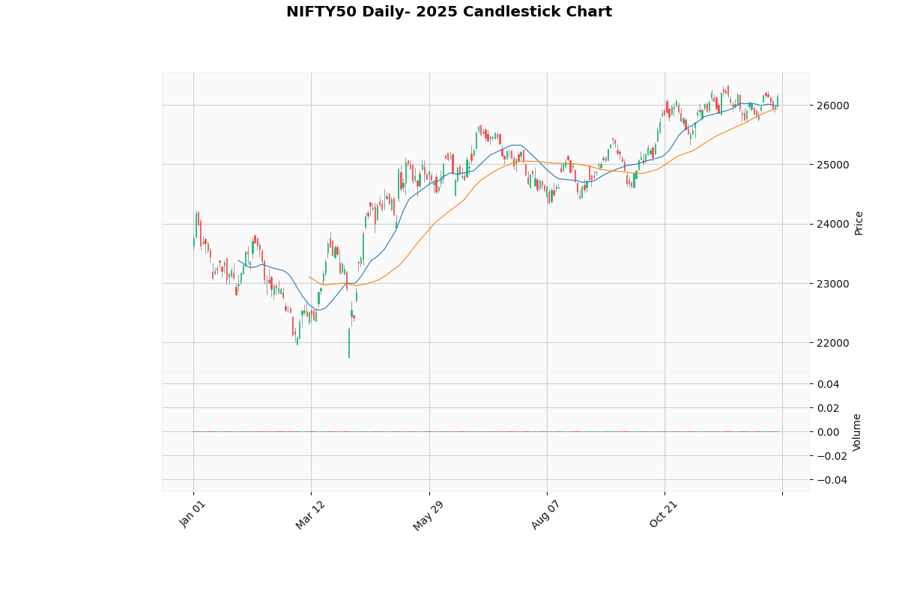
Figure 16 Candelstick Chart (PYTHON)

Justification: The candlestick chart was chosen to visualise NIFTY50’s daily price action (open, high, low, close) in a standard financial format. Candlesticks are widely recognised in the investment community and effectively convey intraday sentiment, volatility, and trend direction through colour (green/red) and wick/body structure. Including volume bars beneath adds context about trading activity.

Bar Chart (Daily Range of movement of Prices)
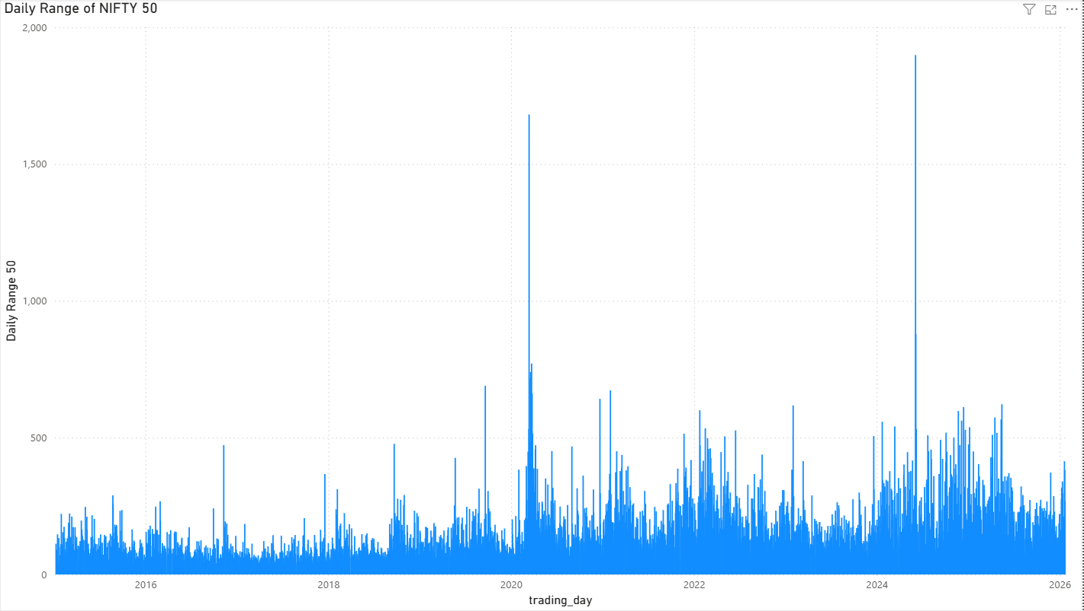
Figure 17 Bar Chart (POWER BI)

Justification: The bar chart was chosen to visualise the daily price range (high – low) of NIFTY50 across the entire period. This visual effectively communicates intraday volatility and price oscillation magnitude on a day-by-day basis, with each bar representing one trading day's range. Bar charts are ideal for comparing discrete values over time, allowing executives to immediately identify periods of high intraday movement (e.g. during market stress) versus calmer periods. The use of DAX to calculate the range (Daily Range = [High] - [Low]) ensured accurate and dynamic computation directly within Power BI, making the visualisation both precise and flexible for filtering or drill-down. This chart provides clear, actionable insight into short-term price instability for risk monitoring.

Waterfall Model
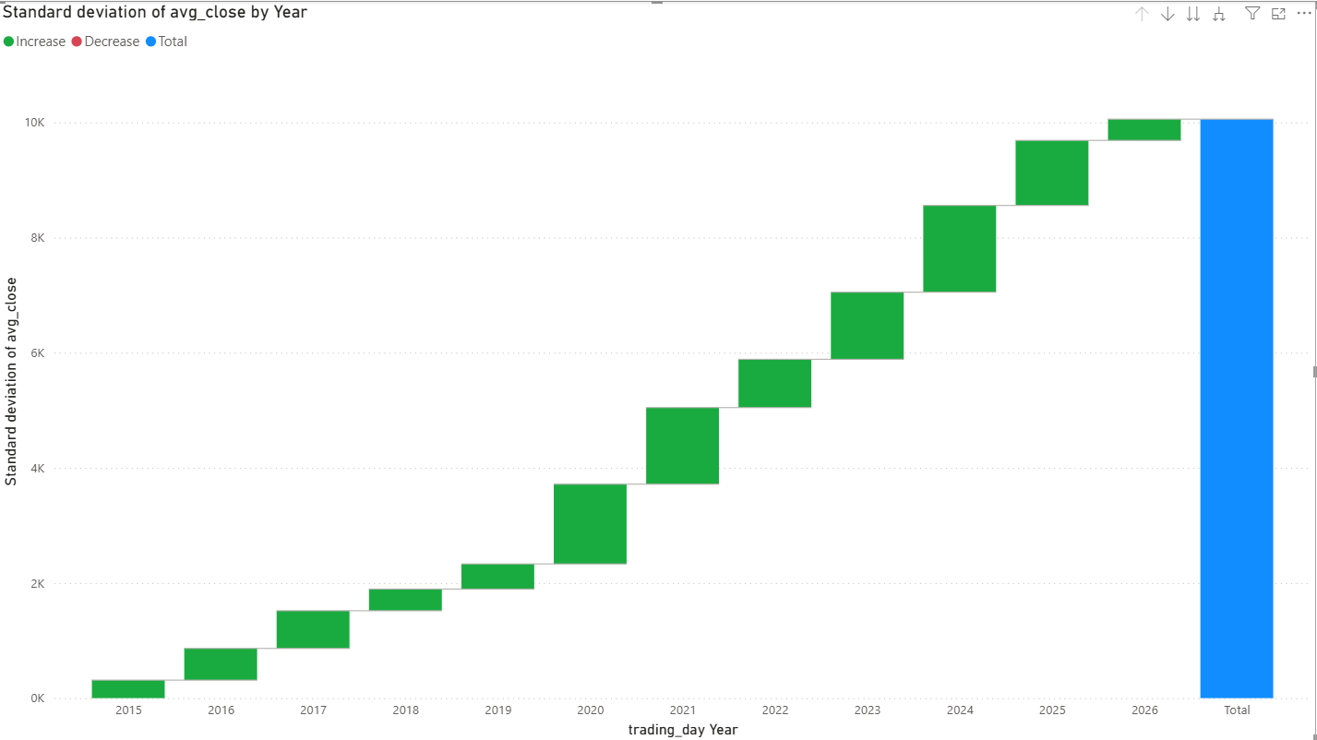
Figure 18 Waterfall chart (POWER BI)
Justification: The waterfall chart was selected to visualise the cumulative contribution of daily returns to the overall performance of the NIFTY50 index over selected periods. This visualisation excels at breaking down the step-by-step build-up (or breakdown) of total return, with green bars representing positive daily contributions and red bars negative ones, culminating in the net change. It provides executives with a clear, narrative-driven view of how individual days or months drove the index’s cumulative outcome, making it easy to identify key inflection points (e.g. major positive runs or sharp drawdowns).

